**Software design**

Student: Jorn Kersten

Student number: 483331

Date: 11-01-2023

Semester: S-DB-IPS3-S3-DB03

Table of contents

User stories 3

Concepts 3

Concept diagram 3

ERD 4

Software architecture 5

# User stories

After an introductory talk, the group wrote down all the things we heard in user stories. We then extracted the functional and non-functional requirements from the user stories and put them into a document. We shared this file with the stakeholder who verified the requirements.

[Requirements on GitHub](https://github.com/WJJCN/Documentation/blob/main/Documentatie/Requirements.md)

# Concepts

## Concept diagram

To have a clear thread for ourselves on how the particular classes should communicate with each other, we created a concept diagram. This also made it easier for us to base the application and ERD on.

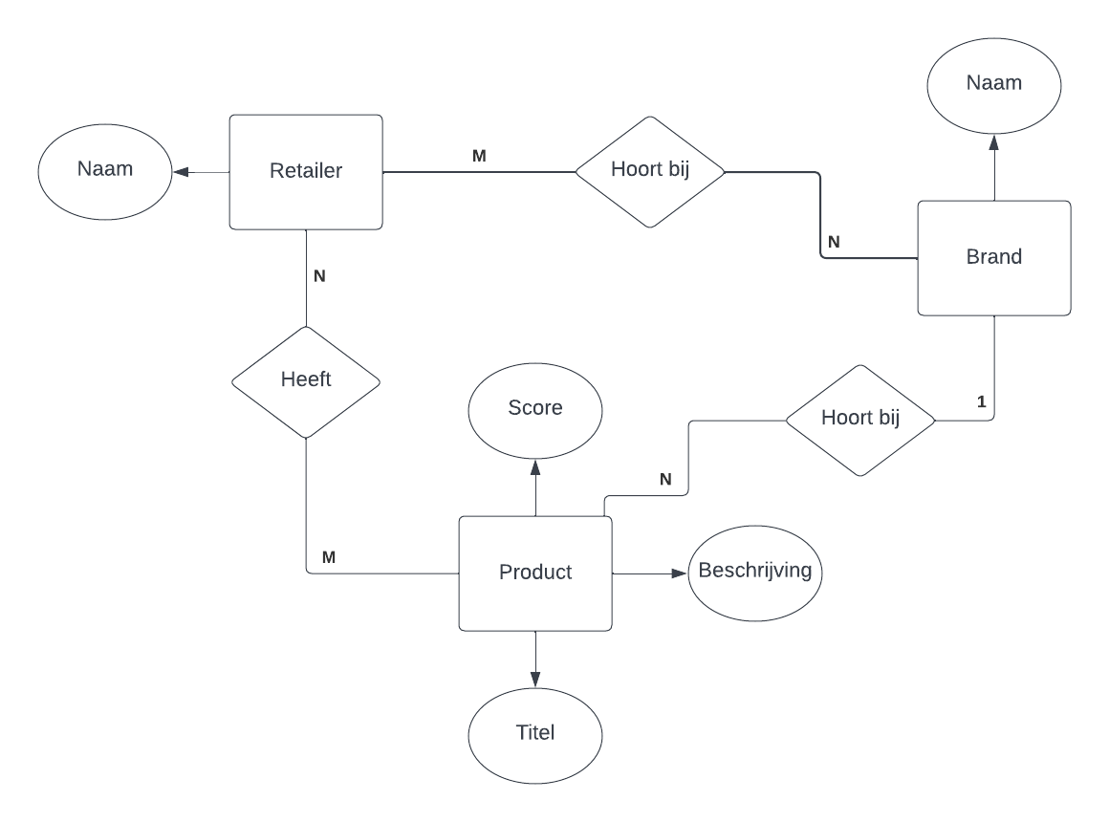

## ERD

Because our data varies a lot in what the names and such are, we cannot use clear fixed tables. Therefore, we chose to use postgressql with no-sql for our database. In the image below, you can see the ERD containing the coarse tables with all the tables' communication with each other.

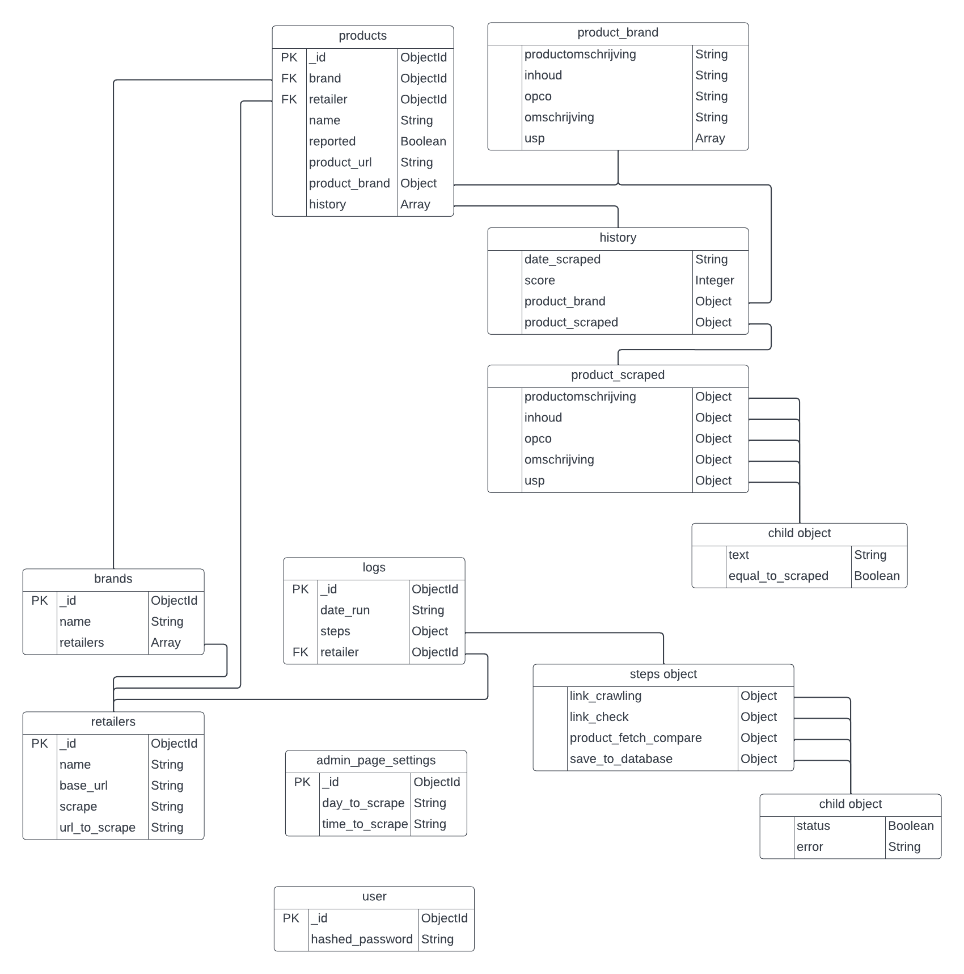

# Software architecture

Figure 1 shows the structure of how users interact with the application over the internet. The same image also shows the communication within the application with the different components. Figure 2 on the next page shows how our architecture is structured on the AWS server. 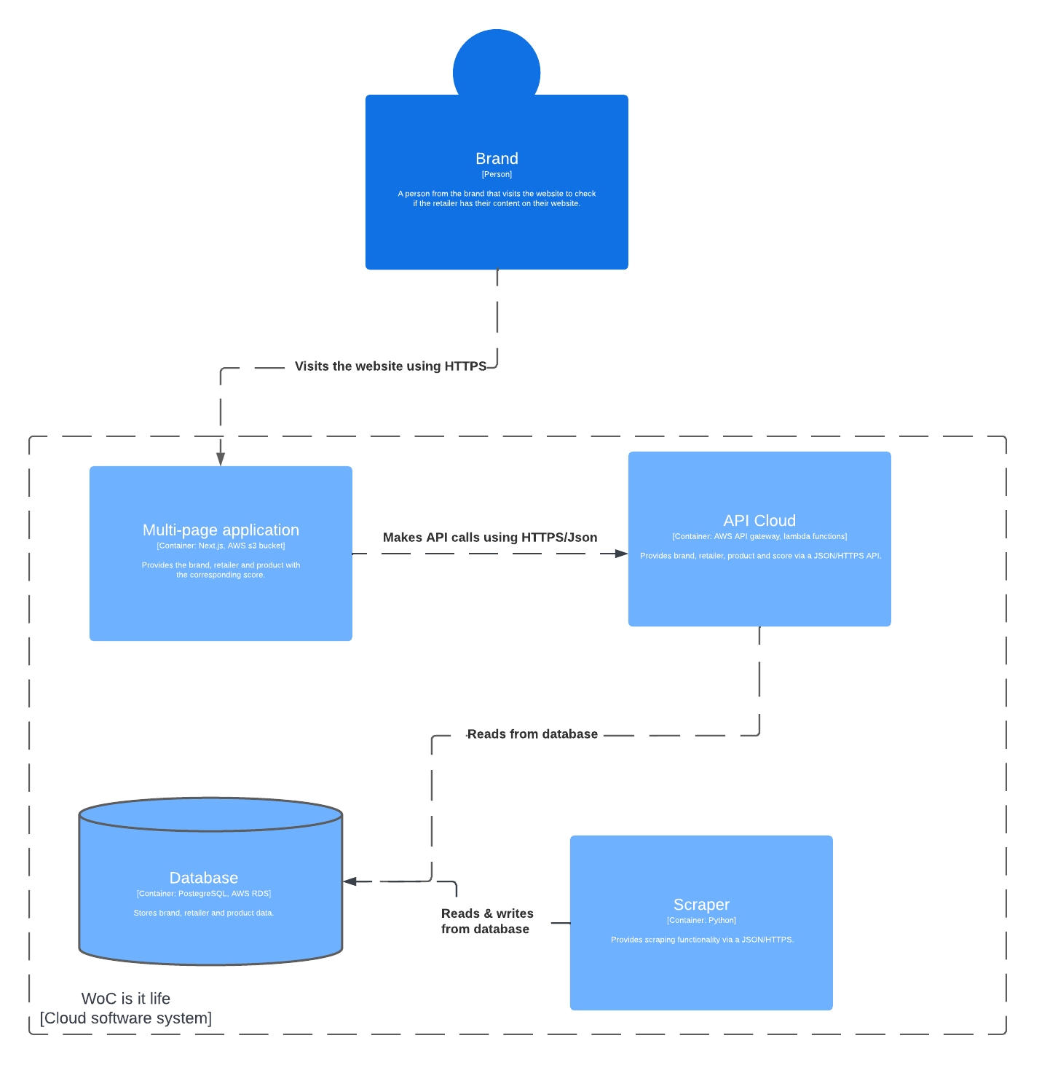

Figure 1

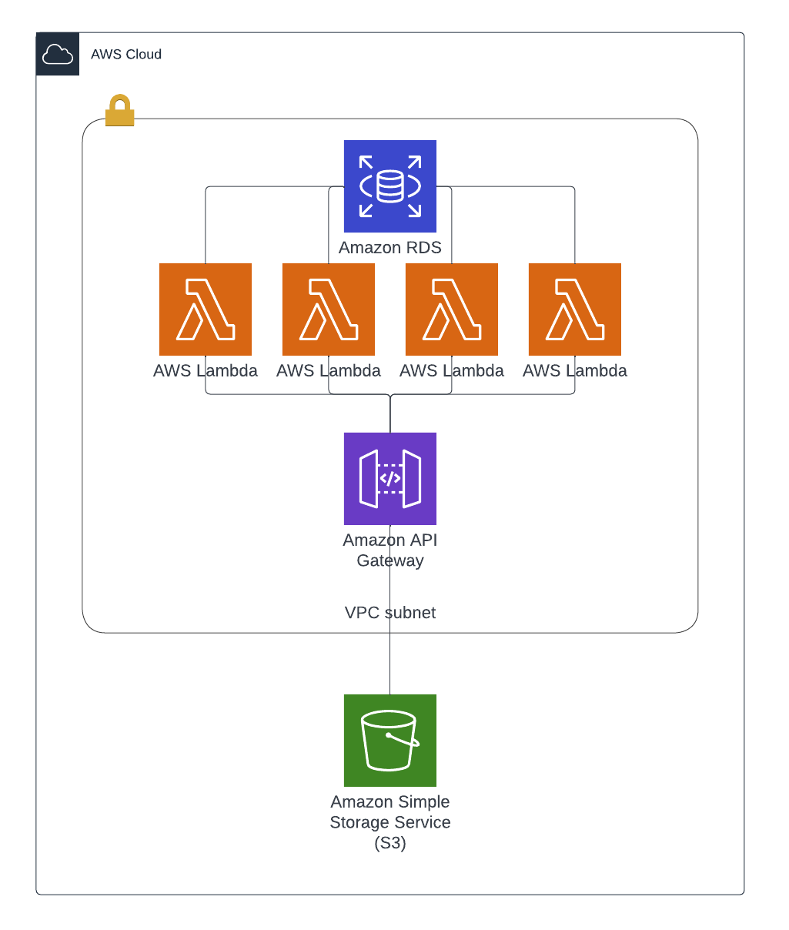

Figure 2